Sprite Color FX
'Sprite Color FX' is a collection of effects about color on sprites of Unity. Works with 'SpriteRenderer' to create a wide variety of cool effects in a fast and easy way. (web, demo #1, demo #2).

Sprite Color Ramp.
This effect uses the brightness of the pixel (not color), and replace it with another color from a ramp generated by a specific tool. In this tool, you can add five colors palettes and generate with one click all the data necessary to change the color of your sprites.
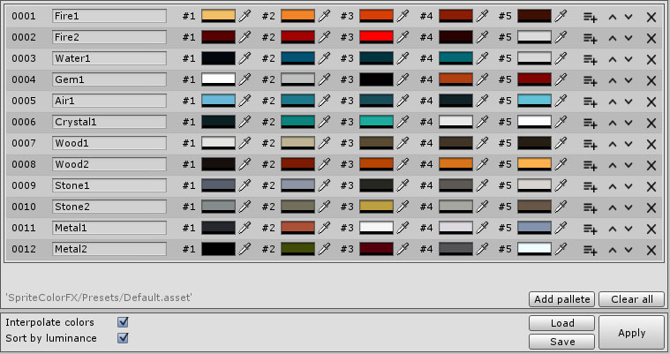
If your sprite was originally like this:
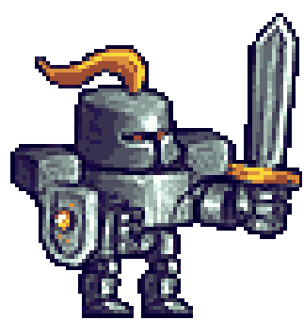

You could generate, for example, all these variants:

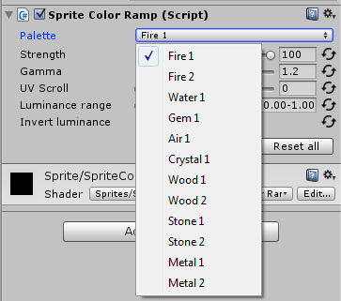
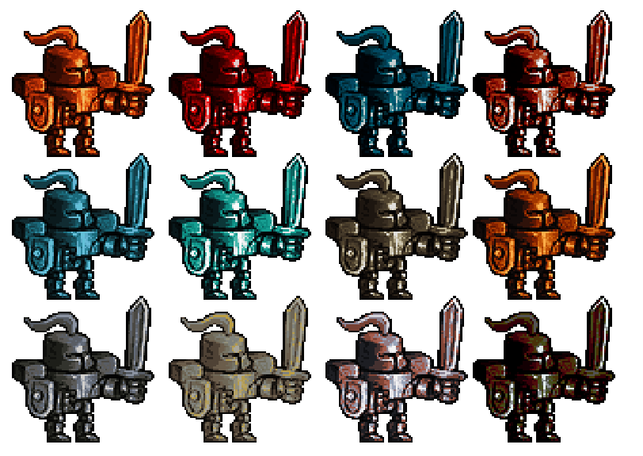

If you only want to modify only certain areas of your sprites, the 'Sprite Color Ramp Mask' component allows you to define up to three different zones. Check out this demo.

Sprite Color Shift.
This effect displaces the color channels (RGB) to create an effect known as chromatic aberration. The displacement can be linear or radial (more effect at the edges and less in the center). Also you can add noise.

This is the effect of the linear mode (left) and radial (right):

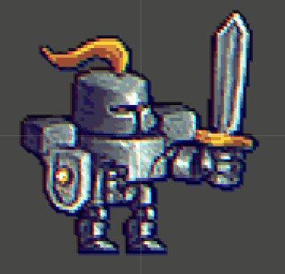
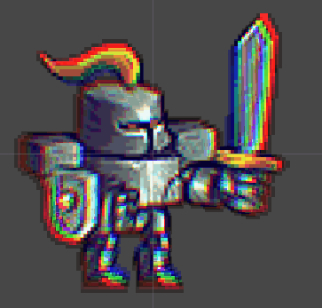

Sprite Color Dissolve.

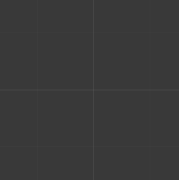
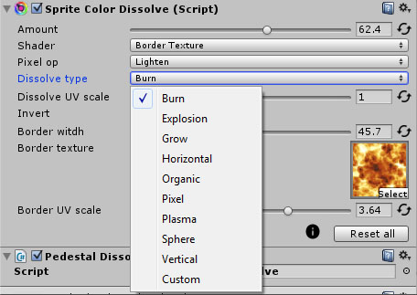
With this effect you can make disappear, or appear, your sprites in a very beautiful ways. To do this, another texture is used to indicates the order where the pixels will disappear.
This texture should be black and white. The darker areas are the first to disappear. For example, a dissolving texture like this:

Makes the sprite dissolved in this way:

'Sprite Color FX' brings some textures that you can select from the 'Dissolve type' field. If you want to use your own, select the type 'Custom'.

Frequently asked questions.

- Can I use the free version (Personal Edition) of Unity3D?
Yes, and with the Pro too.

- What version of Unity should I need?
You need the version 4.5 or higher.

- Does it need any special hardware?
All effects in 'Sprite Color FX' needs a GPU that supports Shader Model 3.0 or higher.

At desktop PCs, any card compatible with DirectX 9.0c are supported (ATI Radeon HD2000 or higher, Nvidia GeForce 8/9/GTX200 or higher or Intel GM965 or higher).

In mobile platforms, any device compatible with OpenGL ES 2.0 should run fine. Please, check the Apple hardware compatibility lists or search for Android Froyo 2.2(API 8) or higher here.
In generall, any device with a decent GPU after the 2008 should work.

- Includes source code?
Yes, all source code is included (also shaders).

